I’m going to the cinema

My name is (name)
(you may want to insert photo of the individual here)

On (day) (date) (month), I’m going to the cinema at (place).

(Insert photo of the cinema chain. Ideally, use a photo of the cinema you are attending. These can be found online in most cases using Google images)

I’m going to the cinema at (time).
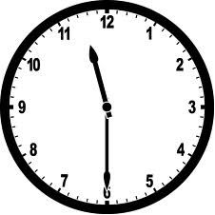
(insert clock photo with the correct time of the film on it)

When I get to the cinema, I will need to get a ticket. I might have to wait in a queue but it won’t take long.
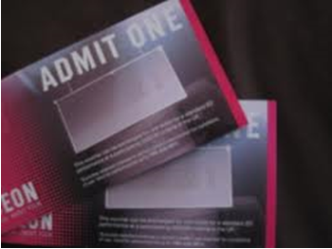

If I want to, I can get something to eat and drink.
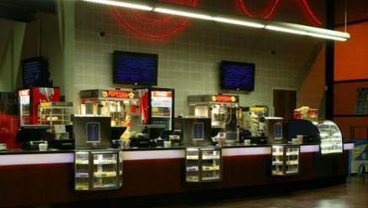
(If the person is bringing their own food, it may be useful to insert photos of the specific foods they’ll be bringing)
Next, I go in to the cinema to watch the film. I need to find a seat and sit down.
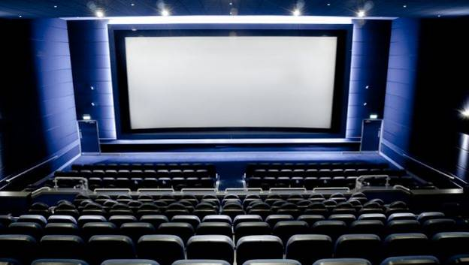

I’m going to see a film called (film title)

(Insert a picture of the film. You can find this through Google.)

The film is about…
(Write a couple of sentences about the film plot. You can find out what the films are about through Google, http://www.imdb.com and watching the trailer on Youtube.)

When the film has ended, I will leave the cinema.
